UNIT II
Bitwise Operators: Exact Size Integer Types, Logical Bitwise Operators, Shift Operators.
Selection & Making Decisions: Logical Data and Operators, Two Way Selection, Multiway Selection, More Standard Functions.
Repetition: Concept of Loop, Pre-test and Post-test Loops, Initialization and Updating, Event and Counter Controlled Loops, Loops in C, Other Statements Related to Looping, Looping Applications, Programming Example: The Calculator Program.

Bitwise Operators
Exact Size Integer Types
- The integer types such as int and long, are machine dependent.
- In one computer the size of int may be 4 bytes, in another computer it may be 2 bytes.
- C allows us to define integer types of sizes 8,16,32,64 byte. They are defined in <stdint.h> header file.
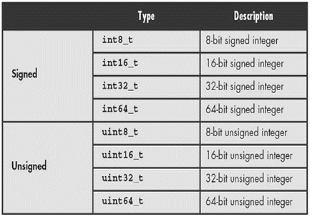
Fixed-size Integer Types
Operators
- Operators which can join together individual constants, variables, array elements and function reference operators and upon data items called as operators.
- An operator is a symbol which operators on a value or a variable.
- An operator is a symbol that tells the compiler to perform specific mathematical or logical function.
- C-language the following are the built-in type of operators:
- Arithmetic operators.
- Increment and Decrement operators.
- Relational operators.
- Logical operators.
- Assignment operators.
- Conditional operators.
- Bitwise operators.
- Special operators.
Arithmetic operators
- An Arithmetic operator performs mathematical operations such as addition, subtraction and multiplication on numerical values.
- Arithmetic operators can applied to any integer or floating point numbers.
Operator | Description | Example
+ | Adds two operands | 20+30=50
- | Subtracts second operand from the first | 20-10=20
* | Multiplies two operands | 2*3=6
/ | Divides numerator by denominator | 6/3=2
% | Modulus operator or remainder after an integer division | 6%2=0
Program for an arithmetic operator
#include<stdio.h>
main()
{
int a=10,b=5,c;
c=a+b;
printf(“%d+%d=%d”,a,b,c);
c=a-b;
printf(“%d-%d=%d”,a,b,c);
c=a*b;
printf(“%d*%d=%d”,a,b,c);
c=a/b;
printf(“%d/%d=%d”,a,b,c);
c=a%b;
printf(“%d%%d=%d”,a,b,c);
}
Output:
10+5=15
10-5=5
10*5=50
10/5=2
10%5=0
Increment and Decrement operators (or) unary operator
- There are three unary operators: unary minus, increment and decrement operators.
unary minus operator (or) negation
- When an operator is preceded by minus sign, the unary operator negates its value.
Example: int a,b=10;
a=-(b)
a=10
Increment operator (++)
- Increment operator ++ increases the value by 1, therefore this operator performs only on a single operand.
Example: int i=1;
i++;
Decrement operator (--)
- Decrement operator -- increases the value by 1.
Example: int i=1;
i--;
- The increment/decrement operator have 2 variants- prefix and postfix
Operator | Action
a++ | Post increment
++a | Pre increment
a-- | Post decrement
--a | Pre decrement

Program using increment and decrement operator
#include<stdio.h>
main()
{
int a=10;
printf(“%d\n”,a); 10
printf(“%d\n”,a++); 10
printf(“%d\n”,a); 11
printf(“%d\n”,++a); 12
printf(“%d\n”,a); 12
printf(“%d\n”,a--); 12
printf(“%d\n”,a); 11
printf(“%d\n”,--a); 10
printf(“%d\n”,a); 10
}
Relational Operators:
- The relational operator checks the relationship between two operands.
- If the relation is true, it returns 1, if the relation is false, it returns 0.
Operator | Meaning of the operator | Example
== | Equal to | 5==3
> | Greater than | 5>3
< | Less than | 5<3
!= | Not equal to | 5!=3
>= | Greater than or equal to | 5>=3
<= | Less than or equal to | 5<3
Program for relational operator
#include<stdio.h>
main()
{
int a=100,b=50;
printf(“%d==%d=%d”,a,b);
printf(“%d>%d=%d”,a,b);
printf(“%d<%d=%d”,a,b);
printf(“%d>=%d=%d”,a,b);
printf(“%d<=%d=%d”,a,b);
printf(“%d!=%d=%d”,a,b);
}
Output:
100==50 =0
100>50 =1
100<50 =0
100>=50 =1
100<=50 =0
100!=50 =1
Logical Operator
- An expression containing returns either 0 or 1 depending upon whether the expression results true or false.
- Logical operators are commonly used in decision making.
Operator | Meaning of operation | Example
Logical AND - && | Logical AND true only if all operands are true | ((0==5)&&(1>5)) equals to 0
Logical OR -|| | Logical OR true only if either one operand is true | ((0==5)||(7>5)) equals to 1
Logical NOT - ! | Logical NOT true only if the operand is 0 | If c=5 then expression !(5==5) equals to 0

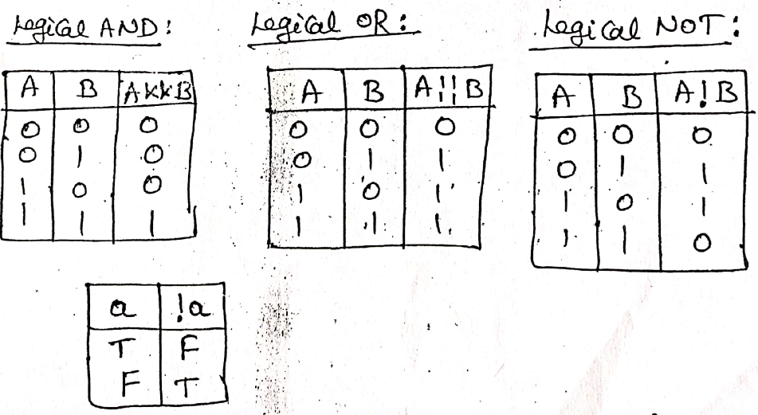
Program for logical operators
#include<stdio.h>
main()
{
int a=10,b=20,c=30,d;
d=(a>b)&&(a>c);
printf(“result is:%d\n”,d); False-0
d=(a<b)&&(a<c);
printf(“result is:%d\n”,d); True-1
d=(a<b)||(a>c);
printf(“result is:%d\n”,d); True-1
d=(a>b)||(a>c);
printf(“result is:%d\n”,d); false-0
d=!(a==b);
printf(“result is:%d\n”,d); false-0
d=!(a<b);
printf(“result is:%d\n”,d); Fasle-0
}
Assignment Operator
- An assignment operator is used to assigning a value to a variable.
- The most common assignment operator is (=).
Operator | Example | Same as
= | a=b | a=b
+= | a+=b | a=a+b
-= | a-=b | a=a-b
*= | a*=b | a=a*b
/= | a/=b | a=a/b
%= | a%=b | a%=b
<<= | Left shift and assignment operator | a<<=2 is same as a=a<<2
>>= | Right shift and assignment operator | a>>=2 is same as a=a>>2
&= | Bitwise AND assignment operator | a&=2 is same as a=a&2
∧= | Bitwise exclusive OR and assignment operator | a∧=2 is same as a=a∧2
∣= | Bitwise inclusive OR and assignment operator | a∣=2 is same as a=a∣2
Program for assignment operators
#include<stdio.h>
main()
{
int x,y;
printf(“enter x & y values”);
scanf(“%d%d”,&x,&y);
printf(“%d\n”,x+=y);
y-=x;
printf(“%d\n”,y);
x*=y;
printf(“%d\n”,x);
y%=x;
printf(“%d\n”,y);
}
Conditional Operator (Ternary Operator ?:)
- The first expression conditional expression is evaluated at first. This expression evaluated to 1, if its true and evaluated to 0, if its false.
conditional expression? exp1:exp2;
- If conditional expression is true, exp1 is evaluated.
- If conditional expression is false, exp2 is evaluated.
condition? true statament:false statament;
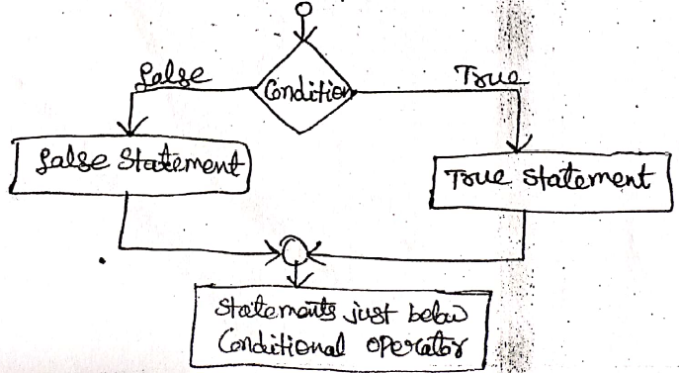
Program using conditional operators
#include<stdio.h>
main()
{
int a,b,i;
printf(“enter a,b values:”);
scanf(“%d%d”,&a,&b);
i=(a>b)?a:b;
printf(“The largest value is:% d”,i);
}
Bitwise Operator
- Bitwise operators are those operators that perform operations at bit level.
- During computation, mathematical operations like: addition, subtraction, multiplication and division are converted to bit level which make processing faster and saves power.
- Bitwise operators cannot be directly applied to primitive data types such as float, double, etc. These are mostly used with the integer data type because of its compatibility.
- The bitwise logical operators work on the data bit by bit, starting from the Least significant bit, i.e. LSB bit towards the Most Significant Bit i.e. MSB bit.
Operator | Meaning | Example
& | Bitwise AND | (A&B)=12
∣ | Bitwise OR | (A∣B)=61
∧ | Bitwise exclusive OR | (A∧B)=49
∽ | Bitwise compliment | (∽A)
<< | Shift left | A<<2=240
>> | Shift right | A>>2=15
- The result of the computation of bitwise logical operators is shown in the table given below.
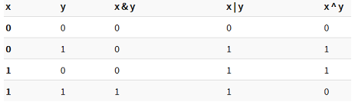
Bitwise AND
- This is one of the most commonly used logical bitwise operators. It is represented by a single ampersand sign (&).
- Two integer expressions are written on each side of the (&) operator.
- The result of the bitwise AND operation is 1 if both the bits have the value as 1; otherwise, the result is always 0. For example:
12 = 00001100 (In Binary) 00001100
25 = 00011001 (In Binary) &00011001
Bit Operation of 12 and 25 00001000 = 8 (In decimal)
Program using Bitwise AND
#include<stdio.h>
int main()
{
int a = 12, b = 25;
printf("Output = %d", a&b);
return 0;
}
Output
Output = 8
Bitwise OR
- It is represented by a single vertical bar sign (|).
- Two integer expressions are written on each side of the (|) operator.
- The result of the bitwise OR operation is 1 if at least one of the expression has the value as 1; otherwise, the result is always 0.For example:
12 = 00001100 (In Binary) 00001100
25 = 00011001 (In Binary) ∣ 00011001
Bit Operation of 12 and 25 00001101 = 29 (In decimal)
Program using Bitwise OR
#include<stdio.h>
int main()
{
int a = 12, b = 25;
printf("Output = %d", a∣b);
return 0;
}
Output
Output = 29

Bitwise Exclusive OR
- It is represented by a symbol (^).
- Two integer expressions are written on each side of the (^) operator.
- The result of the bitwise Exclusive-OR operation is 1 if only one of the expression has the value as 1; otherwise, the result is always 0. For example
12 = 00001100 (In Binary) 00001100
25 = 00011001 (In Binary) ∧ 00011001
Bit Operation of 12 and 25 00001001 = 21 (In decimal)
Program using Bitwise Exclusive OR
#include<stdio.h>
int main()
{
int a = 12, b = 25;
printf("Output = %d", a∧b);
return 0;
}
Output
Output = 21
Bitwise complement operator
- Bitwise compliment operator is an unary operator (works on only one operand).
- It changes 1 to 0 and 0 to 1. It is denoted by ~.Bitwise complement of any number N is -(N+1).
#include<stdio.h>
void main()
{
printf("Output = %d\n",~ 35); printf("Output = %d\n",~ -12);
}
Output: Output = -36
Output = 11
Shift Operators
- There are two shift operators in C programming: Right shift operator and Left shift operator.

Right Shift Operator
- Right shift operator shifts all bits towards right by certain number of specified bits. It is denoted by >>.
212 = 11010100 (In binary)
212 >> 2 = 00110101 [Right shift by two bits]
212 >> 7 = 00000001
212 >> 0 = 11010100 (No Shift)

Left Shift Operator
- Left shift operator shifts all bits towards left by certain number of specified bits. It is denoted by <<.
212 = 11010100 (In binary)
212 <<1 = 110101000 [Left shift by one bit]
212 <<0 = 11010100 (No Shift)
212 <<4 = 110101000000 (In binary) =3392(In decimal)

Example Program:
#include <stdio.h>
int main()
{
int num=212, i;
for (i=0; i<=2; ++i)
printf("Right shift by %d: %d\n", i, num>>i);
printf("\n");
for (i=0; i<=2; ++i)
printf("Left shift by %d: %d\n", i, num<<i);
return 0;
}

Output:
Right Shift by 0: 212
Right Shift by 1: 106
Right Shift by 2: 53
Left Shift by 0: 212
Left Shift by 1: 424
Left Shift by 2: 848

Rotate Shift or Bit Rotation
- A rotation (or circular shift) is an operation similar to shift except that the bits that fall off at one end are put back to the other end.
- In left rotation, the bits that fall off at left end are put back at right end.
- In right rotation, the bits that fall off at right end are put back at left end.
Example:
Let n =11100101 is stored using 8 bits
Left rotation of n by 3 makes n = 00101111 (Left shifted by 3 and first 3 bits are put back in last).
Right rotation of n by 3 => n = 10111100 (Right shifted by 3 and last 3 bits are put back in first).

Special operators
Operator | Meaning
& | Get the address of the variable  Ex:-&a will give address of a
* | This is a pointer to a variable  Ex:- *a
sizeof() | This gives the size of the variable  Ex:- sizeof(char) will give us 1

Selection & Making Decisions
Control Flow
- The term flow of control refers to the order in which a program’s statements are executed.
- C supports two types of decision control statements that can alter the flow of a sequence of instructions.
- Control flow is divided into two types
  - Selection/branching/decision making statement
  - Repetition/ looping/iterative
Selection
- Selection is also called as branching statement (or) decision statement.
- In these statements one group of statement depending on the result of decisions. The result is in the form of two expressions true or false.
- Selection is performed in 2 ways
  - One way selection
  - Two way selection
  - Multi way selection
One way selection
- One way selection is if statement.
- This if statement checks whether the condition inside the parenthesis( ) is true or not, if the condition is true the statement inside the if body will be executed but if the condition is false then the if body is ignored.
Syntax:
if(condition) {
Statement1;
……
Statement n;
}
Statement x;

Flow chart for if
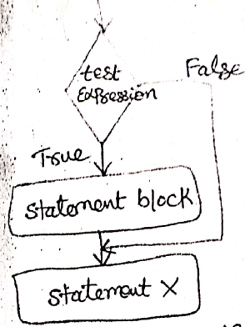
C program to print or to check the greatest number from the given numbers
#include<stdio.h>
main( )
{
int a,b;
printf(“enter a and b values:”);
scanf(“%d%d”,&a,&b);
if(a>b)
{
printf(“a is bigger”);
}
printf(“This is a simplest if statement”);
}
Output:
Enter a and b values: 10 20
This is a simplest if statement
Two way selection
- Two way selection is if else statement.
- An if…else statement is a paired statement used to selectively execute code based on condition.
Syntax:
if(condition) {
Statement block 1;
}
else
{
Statement block 2;
}
Statement x;
- If the value of condition is true, then statement block 1 statements will be executed. If the value of condition is false, then statement block 2 statements will be executed.
- In any case, after the execution, the control will be automatically transferred to the statements appearing outside the block of if.
Flow chart for if else
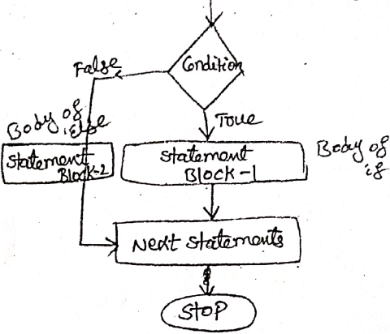
C program to print or to check the greatest number from the given numbers
#include<stdio.h>
int main( )
{
int num=19;
if(num<10)
{
printf("The value is less than 10”);
}
else
{
printf("The value is less than 10”);
}
return 0;
}
Output: The value is greater than 1
Nested-if Statements
- When an if-else is included within an if-else, it is known as nested if statement.
Syntax:

if (condition 1)
{
if(condition 2)
{
Statement block 1;
}
else
{
Statement block 2;
}
}
else
{
if(condition 3)
{
Statement block 3;
}
else
{
Statement block 4;
}
}
Statement x;
- There is no limit to how many levels can be nested, but if there are more than three, it can be difficult to read.
- The statement block may contain single statement or multiple statements.
- Initially the condition 1 is evaluated, if the condition is true again condition 2 is evaluated, if the condition 2 is true again the statement block 1 is executed followed by a next statement.
- Otherwise condition 1 is false then condition 3 is evaluated, if the condition 3 is true statement block 3 is executed followed by the next statement.
- Otherwise statement block 4 is executed followed by next statement

Program using Nested-if program
#include<stdio.h>
int main()
{
int a, b;
printf(“Enter any two integers”); scanf(“%d%d”, &a, &b);
if(a<=b)
{
if (a<b)
printf(“ %d is less than %d”, a,b);
else
printf(“ %d is equal to %d”, a,b);
}
else
prinf(“ %d is greater than %d”, a,b ); return 0;
}
else-if ladder (or) if-else-is (or) if-else chain
- If we are having different-different test conditions with different-different statements then for these kind of programming we need else if ladder.
- else if ladder is not interdependent to any other statements or any other test conditions.
Syntax:
if(condition 1)
{
Statement block 1;
}
. else if(condition 2)
{
Statement block 2;
}
else if(condition 3)
{
Statement block 3;
}
………..
else
{
Statement block x;
}
Statement y;

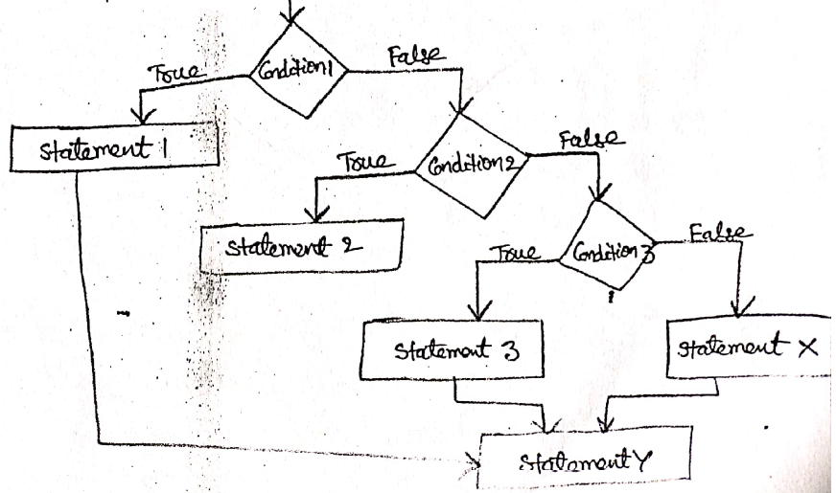
- This constructor is known as else-if ladder. This condition is evaluated from top to bottom.
- The condition is true the statement blocks is executed the control is transferred to the next statement when all the ‘n’ conditions become false then the final else containing the default statement will be executed.
Program to calculate the average of student marks and print the class using else if
#include<stdio.h>
int main( )
{
int a,b,c,sum;
float avg;
printf(“enter the marks”);
scanf(“%d%d%d”,&a,&b,&c);
sum=a+b+c;
avg=sum/3;
printf(“avg=%f\n”,avg);
if(avg>=70)
printf(“first class with distinction”);
else if(avg>=60&&avg<=69)
printf(“first class”);
else if(avg>=50&&avg<=59)
printf(“second class”);
else if(avg>=35&&avg<=49)
printf(“pass”);
else
printf(“fail”);
return 0;
}

Multi-way Selection (switch)
- Decision making are needed when the program encounters the situation to choose a particular statement among many statements, if a program has to choose one block of statement among many alternative, nested-if-else can be used but this makes programming logic complex
- Instead of else-if ladder C has a built-in multi-way decision statement known as a switch.
Syntax: switch(expression)
{
case 1: statement block 1;
break;
case 2: statement block 2;
break;
…………………………
default :statement block x;
}
Statement y;
- The case label end with a semi colon
- When the expression of the switch and the case statement matches, then the statement block of that particular case executed.
- default is also a case that is executed when the value of the variable does not match with any of the values of the case statement.
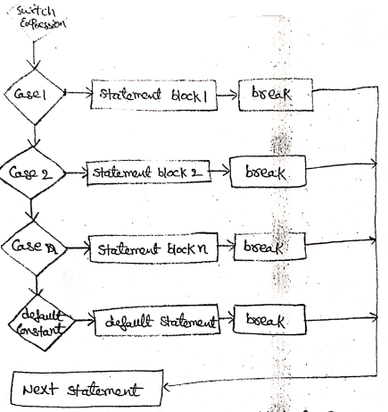
Program to create a simple calculator using switch
#include <stdio.h>
int main()
{
char operator; double n1, n2;
printf("Enter an operator (+, -, *, /): ");
scanf("%c", &operator);
printf("Enter two operands: "); scanf("%lf %lf",&n1, &n2);
switch(operator)
{
case '+': printf("%.1lf + %.1lf = %.1lf",n1, n2, n1+n2);
break;
case '-': printf("%.1lf - %.1lf = %.1lf",n1, n2, n1-n2);
break;
case '*': printf("%.1lf * %.1lf = %.1lf",n1, n2, n1*n2);
break;
case '/': printf("%.1lf / %.1lf = %.1lf",n1, n2, n1/n2);
break;
default: printf("Error! operator is not correct");
}
return 0;
}

More Standard Functions
- The standard functions are built-in functions. In C programming language, the standard functions are declared in header files and defined in .dll files.
- The standard functions can be defined as "the readymade functions defined by the system to make coding more easy".
- The standard functions are also called as library functions or pre-defined functions.
- In C when we use standard functions, we must include the respective header file using #include statement.
- For example, the function printf() is defined in header file stdio.h (Standard Input Output header file). When we use printf() in our program, we must include stdio.h header file using #include<stdio.h> statement.
- C Programming Language provides the following header files with standard functions.
Header file | Purpose | Example function
stdio.h | Provides function to perform standard I/O operations | printf(),scanf()
conio.h | Provides function to perform consol I/O operations | clrscr(),getch()
math.h | Provides function to perform mathematical operations | sqrt(),pow()
string.h | Provides function to handle string data values | strlen(),strcpy()
stdlib.h | Provides function to perform general functions | calloc(), malloc()
time.h | Provides functions to perform operations on time and date | time(), localtime()
ctype.h | Provides functions to perform - testing and mapping of character data values | isalpha(), islower()
setjmp.h | Provides functions that are used in function calls | setjump(), longjump()
signal.h | Provides functions to handle signals during program execution | signal(), raise()
assert.h | Provides Macro that is used to verify assumptions made by the program | assert()
locale.h | Defines the location specific settings such as date formats and currency symbols | setlocale()
stdarg.h | Used to get the arguments in a function if the arguments are not specified by the function | va_start(), va_end(), va_arg()
errno.h | Provides macros to handle the system calls | Error, errno
graphics.h | Provides functions to draw graphics. | circle(), rectangle()
float.h | Provides constants related to floating point data values
stddef.h | Defines various variable types
limits.h | Defines the maximum and minimum values of various variable types like char, int and long

Repetition
Concept of Loop
Loop
- Loop causes program to execute the certain block of code repeatedly until some conditions are satisfied.
- Each repetition is also referred as an iteration or pass through the loop.
- For example if we want to execute some code for 10 times. We can perform it by writing that codes only one time and repeat the execution 10 times using loop.
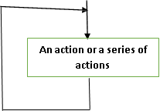
Concept of a Loop
Pre-test and Post-test Loops
- To check the loop control expression either before or after each iteration of the loop.
- In a pre-test loop, the condition is checked before the beginning of each iteration.
- If the condition is true, the code is executed, else the loop is terminated.
- In a post-test loop the actions are executed. Then the control expression is tested(Last).
- If it is true, a new iteration is started; otherwise, the loop terminates. Here the actions are executed atleast once.
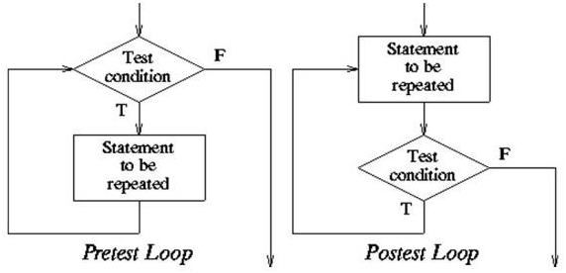
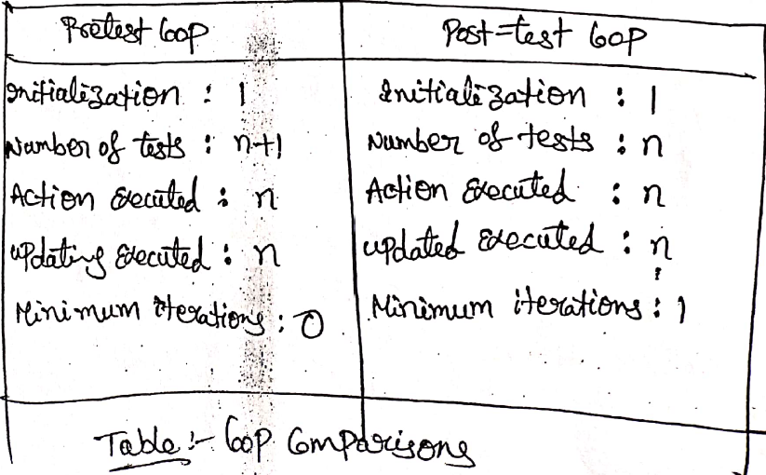
Initialization and Updating
- In loop control expression, two other process, initialization and updating are associated with almost all loops.
Loop initialization
- Before a loop start initialization must be done. It sets the stage for the loop action.
- Initialization may be implicit or explicit.
Loop update
- It is necessary to change the condition true to false, otherwise the loop will be executed indefinitely.
- The actions that cause these changes are known as loop update. Updating is done in each iteration.
- If the body of the loop is repeated ‘n’ times, the updating is also done ‘n’ times.

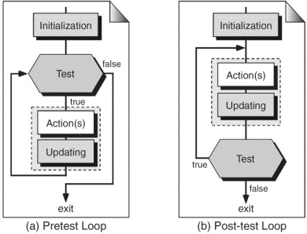
Event and Counter Controlled Loops
Event Controlled Loops:
- In an event-controlled an event that happens in the loops execution block that changes the loops control expression from true to false.
- The program can update the loop control expression explicitly or implicitly.
- In an event-controlled loop pre-test loop, the condition is tested first.If the condition is true, then the action and iterations takes place. If the condition is false, the loop terminates.
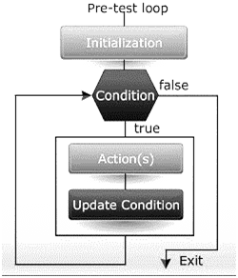
Counter-controlled Loops
- In a counter- controlled loop, the number of loop iterations can be controlled.
- In such a loop, we use a counter, which we must initialize, update and test.
- The number the loop assigned to the counter does not need to be a constant value, to update, we can increment or decrements the counter.
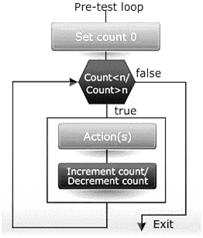
Loops in C
- Loops are divided into 3 types:
  - While /top testes/ entry loop
  - Do-while/bottom tested/post-tested loop/exit loop
  - For loop

While Loop

A while loop is the most straightforward looping structure. The basic format of while loop is as follows:

Syntax:
while(condition)
{
Body of the while loop;
Update expressions;
}
Statement z;
- It is an entry-controlled loop/top checking loop. In while loop, a condition is evaluated before processing a body of the loop
- If a condition is true, then the body of a loop is executed. After the body of a loop is executed then control again goes back at the beginning, and the condition is checked if it is true, the same process is executed until the condition becomes false.
- Once the condition becomes false, the control goes out of the loop. After exiting the loop, the control goes to the statements which are immediately after the loop.
- The body of a loop can contain more than one statement. If it contains only one statement, then the curly braces are not compulsory.
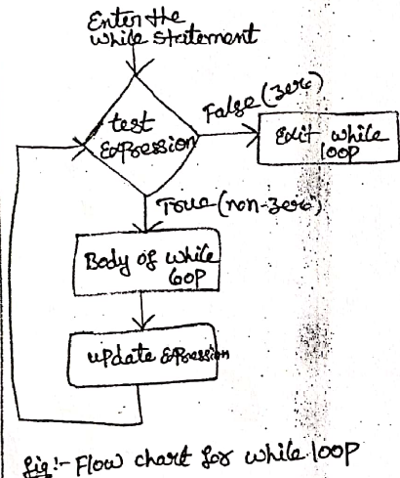
Program to print series from 1 to 10
#include<stdio.h>
int main()
{
int i=1; //initializing the variable
while(i<=10) //while loop with condition
{
printf("%d\t",i);
i++; //incrementing operation
}
return 0;
}

Output:
1 2 3 4 5 6 7 8 9 10

Do-While loop
- A do-while loop is similar to the while loop except that the condition is always executed after the body of a loop.
- It is also called an exit-controlled loop. The basic format of do-while loop is as follows:

Syntax:

do
{
Body of the loop;
Update expressions;
} while(condition);
Statement z;
- In the do-while loop, the body of a loop is always executed at least once.
- After the body executed, then it checks the condition. If the condition is true, then it will again execute the body of a loop; otherwise control is transferred out of the loop.
- Once the control goes out of the loop the statements which are immediately after the loop is executed.
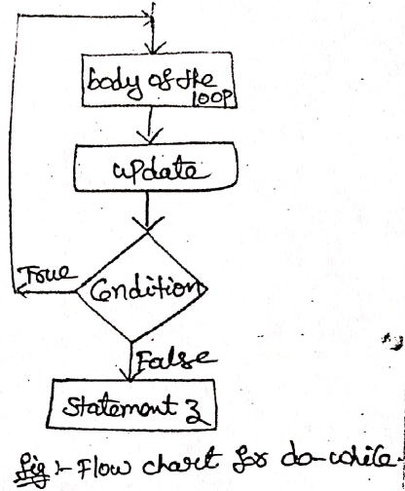
Disadvantage
- The using of do-while loop is that it always executes at least once, even if the user enters some invalid data.
Program to print a table of number 2 using do while loop.
#include<stdio.h>
int main()
{
int i=1; //initializing the variable do //do-while loop
{
printf("%d\t",2*i);
i++; //incrementing operation
}while(i<=10);
return 0;
}

Output:
2 4 6 8 10 12 14 16 18 20

For loop
- A for loop is a more efficient loop structure in 'C' programming. The general structure of for loop is as follows:

Syntax:

for(initialization; condition, increment/decrement)
{
Code to be executed;
}
Statement z;
- The initialization statement of the for loop is performed only once, at the beginning.
- The condition is a Boolean expression that tests and compares the counter to a fixed value after each iteration, terminates the for loop when false is returned.
- The incrementation/decrementation increases (or decreases) the counter by a set value.
Program to illustrate the use of a simple for loop: #include<stdio.h>
int main()
{
int i;
for(i=1;i<=10;i++) //for loop to print 1-10 numbers
{
printf("%d\t",i); //to print the number
}
return 0;
}

Output:
1 2 3 4 5 6 7 8 9 10
Comma Expression
The for loop can have multiple expressions separated by commas in each part.

For example:
for (x = 0, y = num; x < y; i++, y--)
{
statements;
}
Also, we can skip the initial value expression, condition and/or increment by adding a semicolon.

For example:
int i=0;
int max=10;
for ( ; i < max; i++)
{
Printf(“%d\n”,i);
}
Nested for loop
- Loops can also be nested where there is an outer loop and an inner loop.
- For each iteration of the outer loop, the inner loop repeats its entire cycle.
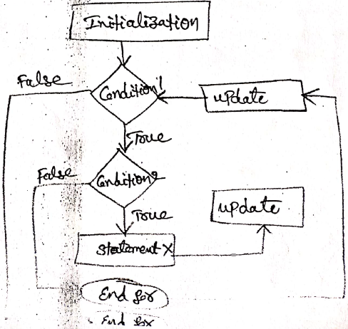
Program to illustrate the use of a simple for loop:
#include<stdio.h>
int main()
{
int limit;
printf(“ Enter the limit: “);
scanf(“%d”, &limit);
for (i=1;i<=limit; i++)
{
for( j=1; j<=i; j++)
printf(“%d”, j);
printf(“\n”);
}
return 0;
}

Output:
Enter the limit: 3
1
12
123
Other Statements Related to Looping
Break Statement
- The break statement is used mainly in the switch statement.
- It is also useful for immediately stopping a loop.
Syntax: break;
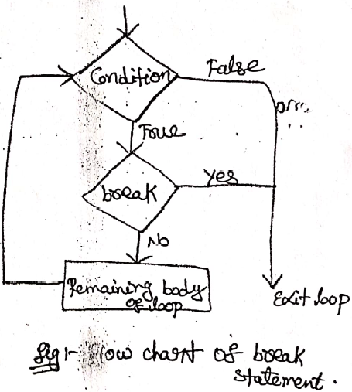
Program to illustrate the use of break statement
#include <stdio.h>
int main()
{
int num = 5;
while (num> 0)
{
if (num == 3)
break;
printf("%d\n", num);
num--;
}
}
Output:
5
4
Continue Statement
- When you want to skip to the next iteration but remain in the loop, we should use the continue statement.
Syntax: continue;
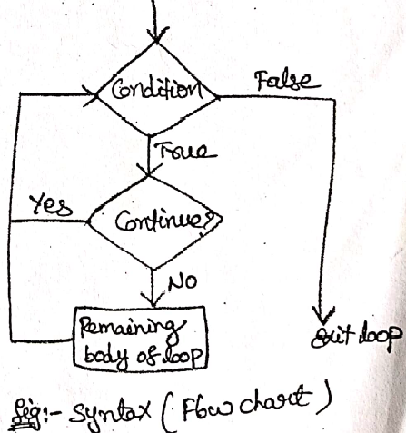
Program to illustrate the use of continue statement
#include <stdio.h>
int main()
{
int num = 7;
while (num> 0)
{
num--;
if (num== 5)
continue; printf("%d\n", num);
}
}
Output:
6
4
3
2
1
So, the value 5 is skipped.
goto Statement
- goto statement is used to jump from one line to another line in the program.
- Using goto statement we can jump from top to bottom or bottom to top.
- To jump from one line to another line, the goto statement requires a label. Label is a name given to the instruction or line in the program followed by colon.
- When we use a goto statement in the program, the execution control directly jumps to the line with the specified label.
Syntax: goto label;
goto label;
…………..
…………..
Label:
statements;
Program to illustrate the use of goto statement
#include<stdio.h>
#include<conio.h>
void main()
{
clrscr();
printf("We are at first printf statement!!!\n");
goto last;
printf("We are at second printf statement!!!\n"); printf("We are at third printf statement!!!\n");
last:
printf("We are at last printf statement!!!\n");
getch() ;
}

Looping Applications
- There are four common applications for loops:
  - Summation
  - Product
  - Smallest or Largest
  - Inquiries.
Summation
- Many numbers can be added if the add operator is used in loop.[sum]
Product
- Product loop can be used to raise a number to a power and to calculate the factorial of a number. [product]
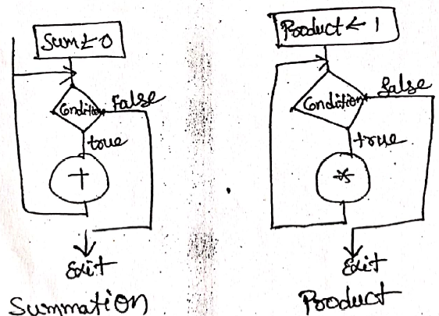
Smallest or Largest
- Loops can be used to determine the smallest or largest element among series of data. [Arrays]
- By using conditional expression or operator.
Inquiries
- Two basic inquiry types are any and all.
- Inquiry type any is used when we have a list of data and want to know if at least one of them meet some given criteria.
- Inquiry type all is used when we have a list of data and want to make sure that each and every one of them meet some specified criteria. [or; and].
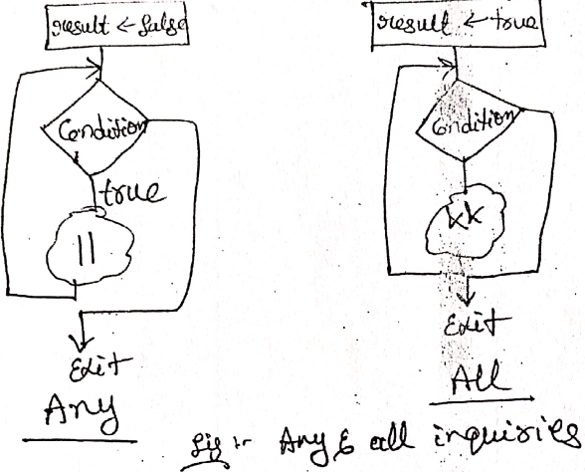
Programming Example: The Calculator Program
#include <stdio.h>
int main()
{
// declare local variables
char opt;
int n1, n2;
float res;
printf (" Choose an operator(+, -, *, /) to perform the operation in C Calculator \n ");
scanf ("%c", &opt); // take an operator
if (opt == '/' )
{
printf (" You have selected: Division");
}
else if (opt == '*')
{
printf (" You have selected: Multiplication");
}

else if (opt == '-')
{
printf (" You have selected: Subtraction");
}
else if (opt == '+')
{
printf (" You have selected: Addition");
}
printf (" \n Enter the first number: ");
scanf(" %d", &n1); // take fist number
printf (" Enter the second number: ");
scanf (" %d", &n2); // take second number

switch(opt)
{
case '+':
res = n1 + n2; // add two numbers
printf (" Addition of %d and %d is: %.2f", n1, n2, res);
break;

case '-':
res = n1 - n2; // subtract two numbers
printf (" Subtraction of %d and %d is: %.2f", n1, n2, res);
break;

case '*':
res = n1 * n2; // multiply two numbers
printf (" Multiplication of %d and %d is: %.2f", n1, n2, res);
break;

case '/':
if (n2 == 0) // if n2 == 0, take another number
{
printf (" \n Divisor cannot be zero. Please enter another value ");
scanf ("%d", &n2);
}
res = n1 / n2; // divide two numbers
printf (" Division of %d and %d is: %.2f", n1, n2, res);
break;
default: /* use default to print default message if any condition is not satisfied */
printf (" Something is wrong!! Please check the options ");
}
return 0;
}
Output:
Choose an operator(+, -, *, /) to perform the operation in C Calculator
+
You have selected: Addition
Enter the first number: 10
Enter the second number: 20
Addition of 10 and 20 is: 30.00

